Guinea

## Population Data

The data set shows the political stability estimate of the country each year.

## # A tibble: 23 x 5  
## country iso3c date population popCategory5  
## <chr> <chr> <dbl> <dbl> <chr>   
## 1 Guinea GIN 1996 7463782 small   
## 2 Guinea GIN 1997 7662075 small   
## 3 Guinea GIN 1998 7860781 small   
## 4 Guinea GIN 1999 8054743 small   
## 5 Guinea GIN 2000 8240730 small   
## 6 Guinea GIN 2001 8417081 small   
## 7 Guinea GIN 2002 8586074 small   
## 8 Guinea GIN 2003 8753093 small   
## 9 Guinea GIN 2004 8925743 small   
## 10 Guinea GIN 2005 9109581 small   
## 11 Guinea GIN 2006 9307425 small   
## 12 Guinea GIN 2007 9518162 small   
## 13 Guinea GIN 2008 9738792 small   
## 14 Guinea GIN 2009 9964469 small   
## 15 Guinea GIN 2010 10192176 small   
## 16 Guinea GIN 2011 10420471 small   
## 17 Guinea GIN 2012 10652029 small   
## 18 Guinea GIN 2013 10892810 small   
## 19 Guinea GIN 2014 11150977 small   
## 20 Guinea GIN 2015 11432088 small   
## 21 Guinea GIN 2016 11738441 small   
## 22 Guinea GIN 2017 12067539 small   
## 23 Guinea GIN 2018 12414318 small

# Population growth data

## # A tibble: 23 x 5  
## country iso3c date popGrowth popGrowthCat5   
## <chr> <chr> <dbl> <dbl> <chr>   
## 1 Guinea GIN 1996 2.64 high growth rate   
## 2 Guinea GIN 1997 2.62 high growth rate   
## 3 Guinea GIN 1998 2.56 high growth rate   
## 4 Guinea GIN 1999 2.44 moderate growth rate  
## 5 Guinea GIN 2000 2.28 moderate growth rate  
## 6 Guinea GIN 2001 2.12 moderate growth rate  
## 7 Guinea GIN 2002 1.99 moderate growth rate  
## 8 Guinea GIN 2003 1.93 moderate growth rate  
## 9 Guinea GIN 2004 1.95 moderate growth rate  
## 10 Guinea GIN 2005 2.04 moderate growth rate  
## 11 Guinea GIN 2006 2.15 moderate growth rate  
## 12 Guinea GIN 2007 2.24 moderate growth rate  
## 13 Guinea GIN 2008 2.29 moderate growth rate  
## 14 Guinea GIN 2009 2.29 moderate growth rate  
## 15 Guinea GIN 2010 2.26 moderate growth rate  
## 16 Guinea GIN 2011 2.22 moderate growth rate  
## 17 Guinea GIN 2012 2.20 moderate growth rate  
## 18 Guinea GIN 2013 2.24 moderate growth rate  
## 19 Guinea GIN 2014 2.34 moderate growth rate  
## 20 Guinea GIN 2015 2.49 moderate growth rate  
## 21 Guinea GIN 2016 2.64 high growth rate   
## 22 Guinea GIN 2017 2.77 high growth rate   
## 23 Guinea GIN 2018 2.83 high growth rate

## Population trend

The plot shows the population trend of the country.

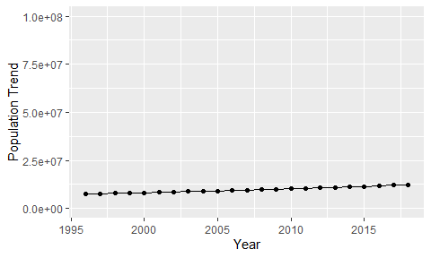

Political Stability Trend

# Population growth trend

The plot shows the population growth rate trend of the country.

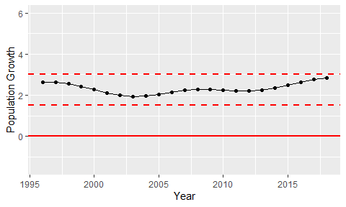

Population Growth Trend